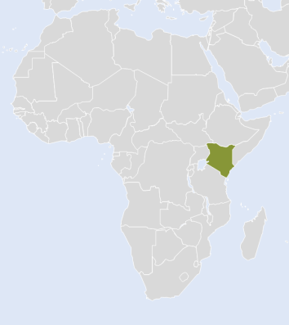
Miss Mary Wanjiku received about 2.5 acres of uncultivated land from the Kenyan government one year ago and set out to make a living as a farmer. Mary’s farm is busy with 3 dairy cows grazing on pastures and a field of 1 acre planted with tomatoes. She sells the products on the local markets.

Country Case Card – Kenya
Water Requirement Tool, Pump Sizing Tool,
Payback Tool, Farm Analysis Tool, Soil Tool
Version 4 (25.05.2022)
Mary’s asset portfolio boasts of several equipment including a small warehouse, a tiller and a livestock shed. Most of the equipment was purchased from a loan which she took in the beginning of the year. Labour is provided by family members for free during peak periods i.e. planting and harvesting. However, two employees earning KES 18,000 each per month are stationed in the farm for half a year to ensure smooth operations during the labour intensive periods.

- Mary pays a monthly KES 4,000 as land tax and KES 1,000 for a local savings group.
- To date, the farm has bought a total of 60 kg in local seeds at average price of KES 100 per kg. 70 kg of fertiliser (priced at KES 50 per kg) and 150 litres of herbicides (priced at KES 200 per litre) have gone into the farm.
- Fuel for machinery (planting, harvest, processing) is at KES 79 per litre. For one planting season approximately 50 litres are needed. Per planting season, repair and maintenance costs of KES 30,000 occur.
- The milk yield per year results in an average daily yield of 10 litres per cattle with the market price being KES 50 per litre.
Farm Analysis
- What is the farm’s gross income?
- What is the farm’s total expense?
- What is the farm’s total variable cost?
- What is the farm’s gross profit?
- What is the highest variable cost? ffff

During her time as a farmer, Mary has seen the weather change for the worse, making it hard to succeed with her farm. “When the rains were good we had good harvests”, she remembers from her childhood years. But nowadays the rains are unpredictable and unevenly distributed. She is considering utilising intensive irrigation from now forward, using an earth canal supplied flood irrigation system. This would give her the opportunity to start a second growing period in September.
First planting period is in the beginning of March.

Water Requirement
- Only one growing season, starting in March (flood irrigation):
  - In which month is the highest irrigation water need?
  - What is the total highest daily irrigation water need?
- With a second growing period with planting in September (flood irrigation) :
  - In which month is the highest irrigation water need?
  - What is the total highest daily irrigation water need?
- What is the highest daily water pumping need, for the two growing periods (if she would use micro sprinkler irrigation) and for her dairy cows?
- What is the pump utilisation rate when having one or two growing periods under micro sprinkler?

Version 4 (25.05.2022)

You do a first calculation after which Mary decides for a micro sprinkler system and will prospectively implement a second growing season. She can use a well with an estimated yield of 50 m³/hour. However, the local agricultural extension officer advised not to extract more than half the water. Measurements show that the groundwater level is at H_{s}= 20 m below the well surface and the drawdown of extracting water should be D= 2 m. She would be pumping water to an elevated tank with a H_{e}= 10m difference in elevation between the surface of the well and the base of the reservoir. A water meter and fertigation / filter system are installed and the loss in each of these is 2 m. The reservoir is sitting on the ground and
the inlet is H_{t}= 2m above ground and 200m away from the well, using a 1 ½” diameter pipe and three 90° elbows.
The water pumped into the tank and stored there would be used for both irrigation and filling the water troughs for her livestock, which are located down the hill, H_{o}= 10 m in elevation below the tank outlet. The manufacturer’s datasheet for sprinkler irrigation shows pressure requirements of 0.5 bar. For the irrigation pipelines she also uses 1 ½ “ PVP-tubes, three 90° elbow connectors, and one check valve. The distance from the tank to the field is around 20 m, and she needs a total of 30 m pipeline length for the lateral feeder tubes going into her tomato fields.

Pump Sizing
- What is the Total Dynamic Head of the pumping system?
- Which is the lowest power (kWp) required (solar deration losses of 25 %)? KWp
- How big is the surface of solar panels to be installed?
- From a neighbor who changed the water system, Mary could get PVP-tubes of 1” for her irrigation for free. Should she accept this friendly offer?

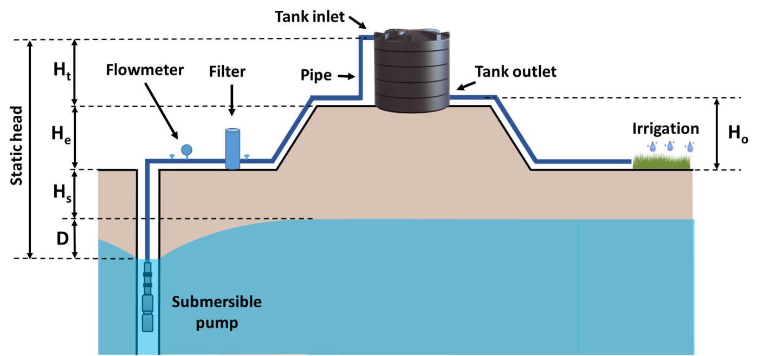

The local agricultural extension engineer performed a soil test to determine the soil texture. The results showed that the soil on Mary’s farm contains 10% sand, 5% clay and 85% silt.

Version 4 (25.05.2022)

Mary was also advised that by using the new irrigation system, she can only apply 20 mm of irrigation water per day and at the beginning of the irrigation season, the soil usual contains around 50% of the water needed for irrigation.
Mary knows from neighboring farmers that she does not need to water tomatoes every day. She figures that she might need a tank to store water so that she has more control over when to irrigate.

Soil
- What is the type of the soil on Mary’s farm?
- Which is the highest number of irrigation events per month? ____ in the month of

- Which is the minimum water storage capacity needed if she irrigates daily?

Mary is considering various options for undertaking the daily water pumping in order to satisfy the water need for her tomatoes. Using irrigation, she will improve the current yield by 50%, while also adding an additional harvest. Three employees now work the whole year on the farm.
Payback Tool
- What it the initial investment cost for each option:
  - Solar? Grid? Diesel?
- What is the internal rate of return (IRR) for each option:
  - Solar? Grid? Diesel?
- What is the break-even point for each option:
  - Solar? Grid? Diesel?
- When does solar break-even with diesel and grid?
You used the Farm Analysis Tool to project her new profit, which will be at………….KES / year, which she will invest entirely in irrigation. Now she can determine how solar compares to other pumping options

Location Data

Country Case Card II – Kenya
Data Sheet

Version 4 (25.05.2022)

Country | Kenya
Location | Taita Taveta
Longitude | 38.55
Latitude | -3.33
Exchange rate | 10,000 KES = 85 €

Climate Data

 | Jan | Feb | Mar | Apr | May | Jun | Jul | Aug | Sep | Oct | Nov | Dec
Mean daily temperature in °C | 25.5 | 25.0 | 24.6 | 23.8 | 23.9 | 23.5 | 23.0 | 23.0 | 23.6 | 23.9 | 23.6 | 23.8
Rainfall in mm/month | 45.0 | 33.0 | 69.3 | 142.8 | 109.8 | 38.1 | 27.0 | 21.6 | 18.3 | 48.3 | 97.2 | 86.1
Solar irradiation in kWh/m² day | 6.2 | 6.6 | 6.0 | 5.3 | 4.6 | 4.3 | 4.4 | 4.7 | 5.6 | 5.9 | 5.6 | 5.8

Assets and equipment

Item | Current Value (KES) | Age
Tiller | 50,000 | 1
Livestock Shed | 250,000 | 1
Warehouse | 250,000 | 1

Economics and financing

Inflation | 11.48 %
Discount rate | 16 %
Annual profit margin increase | 10 %
Annual fuel price increase | 3.84 %
Alpha Bank Loan | Amount | KES 600,000
 | Credit Period | 3 years
 | Annual interest rate | 16 %

Crop Acreage and yield

Crop | Cultivated area (acre) | Estimated yield per season (kg per acre) | Estimated market price (KES per kg)
Tomatoes | 1 | 20,000 | 25

Livestock and milk yield per day

Livestock | N. of livestock | Estimated milk yield per day (l per cow) | Estimated market price (KES per l) | Days of milking per year
Dairy Cows | 3 | 10 | 50 | 300

Solar components

Version 3 (17.03.2022)

Solar Option | Costs in KES | Life span in years
Solar panels | 400,000 | 20
Control unit | 50,000 | 5
Motor pump | 200,000 | 7
Wires / tubes | 20,000 | 5
Water storage | 55,000 | 20
Irrigation system | 80,000 | 5
Installation cost | 25,000
Maintenance cost | 6,000 / year

Grid components
Grid Option | Costs in KES | Life span in years
Motor pump | 150,000 | 5
Wires / tubes | 50,000 | 5
Water storage | 55,000 | 20
Irrigation system | 80,000 | 5
Installation cost | 15,000
Maintenance cost | 5,000 / year
Electricity cost | 20.73 / kWh
Pump electricity demand | 0.75 kW
Pump water output | 6 m³ / hour

Diesel pump components
Diesel Option | Costs in KES | Life span in years
Diesel Generator | 150,000 | 3
Motor pump | 150,000 | 5
Wires / tubes | 50,000 | 5
Water storage | 55,000 | 20
Irrigation system | 80,000 | 5
Installation cost | 25,000
Maintenance cost | 30,000 / year
Diesel cost | 79 / litre
Pump diesel demand | 1 litre / hour
Pump water output | 6 m³ / hour

